FOUNDATION FOR VIRTUAL AND AUGMENTED REALITY SYSTEMS
Lecture43
Lec-43: System Implementation
Hello and welcome to the NPTEL MOOC course on Foundations for Virtual and Augmented Reality Systems. We are currently discussing the implementation stage of the development of the system. So essentially we will continue our discussion on system implementation. Now in this lecture we are discussing the two remaining stages. In the previous lecture we talked about
design in the design prototype evaluate cycle of an interactive system development life cycle. In this lecture, we are covering the other two: prototype and quick evaluation of prototypes. Out of these two, in the previous part of the lecture, we started our discussion on prototyping techniques and in this lecture also, in this part of the lecture also, we are going to continue with our discussion on prototyping. And also, we are going to talk about expert evaluation techniques.
So, earlier we talked about different categories of prototypes and different prototype building approaches. Just to recollect, we have two categories of prototypes. One is horizontal, one is vertical. And also, we have three building approaches: low fidelity, medium fidelity, and high fidelity. Along with that, there is of course, the Wizard of Oz approach.
Now let us talk about prototype usage: how to use the prototypes. So, one way to use it is basically just to use it for a quick evaluation and then discard it. So, these are called throwaway prototypes. So, in this case, the prototypes are discarded after use. Cardboard mockups and paper sketches which are low fidelity are mainly suitable for
such treatments because those are less costly and even if we discard them, we are not going to incur significant cost. Another condition for throwaway prototypes is that they should be easy to create and should be fast to create. So, we should be able to create them rapidly and easily. If these conditions are not met, then the throwaway prototypes working with them becomes quite expensive as is obvious. Next is the incremental prototypes.
In this case, the system is designed into units or modules. Each unit is separately prototyped and tested and afterwards it is integrated into the overall system. So, that is incremental prototypes. Finally, we have evolutionary prototypes. In this case, the whole system is prototyped and tested.
So, in the case of incremental, we have divided the system into modules based on the system design and each module is separately prototyped, tested, and then they are put together to come up with the whole system. In the case of evolutionary prototypes, we start with the simpler version of the system, test it, refine it, then add more functionalities and in that way we evolve the prototype into the full system. So, based on the testing results, the prototype can be altered and eventually it becomes the final product.
So, it is not that separate different modules are prototyped and combined together; it is the whole system from the very beginning. So, those are different ways prototypes can be used. So, we have covered different categories of prototypes, different building approaches, and different ways prototypes can be used. Now, let us move to the other part of the design prototype evaluate lifecycle, that is how to evaluate prototypes quickly. So, essentially this quick evaluation technique is also known as expert evaluation.
Why so? We will learn and we are going to learn in brief what this expert evaluation technique is. Just to put things into perspective, let us recollect, quickly recollect the overall interactive system development lifecycle. We have the feasibility study stage followed by the requirement gathering analysis stage followed
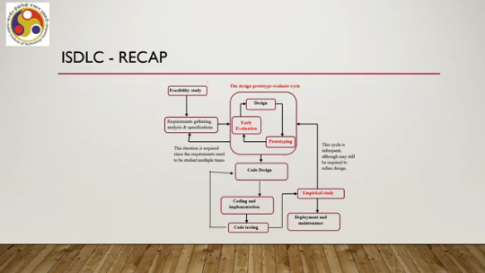
by the design prototype evaluate cycle, where we have the design stage already discussed in the previous lecture. We just finished our discussion on prototyping and now we are going to talk about the early evaluation or quick evaluation or expert evaluation of the prototypes. These are followed by The coding and implementation stage comprises code design, coding, and code testing, which is eventually followed by the empirical study or usability study stage. We will learn about usability studies in a later part of this lecture.
Once everything is done, we go to the deployment stage. So, now we will be talking about early evaluation or quick evaluation of the prototypes. The basic idea is that these evaluation techniques are used for quick and cheap evaluation. That is, we are not going to spend too much time or too many resources on evaluating our prototype. Typically, a robust evaluation technique involves recruitment of suitably skilled evaluators,
some sort of resources, building of a setup for evaluation, and all these things require some resources. Whereas the idea of quick evaluation or expert evaluation is to do the evaluation at an early stage of the design without spending too much time or resources. So, they are typically done at the early stages of design, as you can see from the interactive system development life cycle. Now, in order to perform the quick and cheap evaluation, we require two things. First is at least a low-fidelity prototype; that is, higher quality prototypes are better, but at least we require a low-fidelity prototype and a team of evaluators.
Of course, that is quite obvious because without evaluators, we cannot evaluate anything. Now, this evaluation team is unique. It may be the design team itself or may include other skilled designers who have some knowledge and skill in the domain of the problem. Optionally, few end users may also be included. Note that here we are testing usability.
The primary condition of usability testing is that we must involve the users. However, in the curious case of quick evaluation, Involvement of end users may be optional. Primarily we engage design team members or people familiar with the design problem as evaluators. Why so?
Because we are assuming that they are the experts in the domain of the problem and they have as good experience as a user. So their feedback is likely to reflect that of the users. Now since identifying And engaging design team members is much, much less complicated as compared to engaging a full-fledged evaluation team involving end users. So, it is likely to be quick and cheap.
Now, the evaluation team should have at least three to five members. More is, of course, always welcome, but three to five should be sufficient. Now, each team member evaluates individually and produces a report. So, the prototype is presented to each evaluator, each evaluator evaluates it independently and produces a report. The report contains a list of usability issues as perceived by the evaluator.
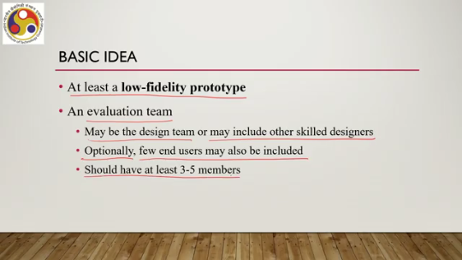
At the end, all these reports are combined to produce a final list of usability issues. Now, this combination, of course, is done by the design team, or the lead of the team. There are different ways to perform this quick evaluation. Let us learn two of such expert evaluation techniques.
The first technique is called cognitive walkthrough. Now, this is a usability inspection method. Essentially, we identify usability problems by inspecting the prototype. The requirements for performing a cognitive walkthrough is at least a low-fidelity prototype with support for several tasks. So, essentially that refers to a vertical prototype, whether built using low-fidelity approach or medium-fidelity approach.
High-fidelity approach, of course, is more welcome; however, that involves time and cost. So, we require at least a low-fidelity vertical prototype, a 3 to 5 member team as discussed earlier, and with that we can perform the evaluation. Now, let us try to understand the evaluation technique in terms of an example. So, first we have to make a prototype.
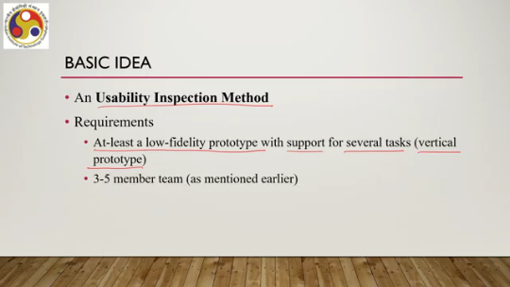
So, let us consider a simple calendar application. In our application, we show only months on the first screen. Once a user selects a month, another screen appears showing dates in that month. A user can select any date and add some note. What are the tasks that a user can do with this interface?
First, let us identify the tasks. There can be many tasks that can be done. Some of those are selection of a month, selection of a day of a month, addition of some note, getting back to month view from the day view and so on. Now, to perform the cognitive walkthrough, we should make a prototype that supports more than one of these tasks.
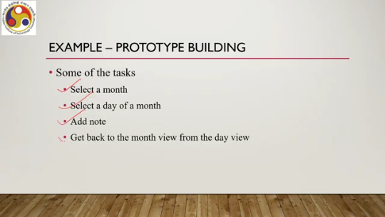
We can make, as we have seen earlier during our discussion on low-fidelity prototypes, simple paper prototypes for these tasks using the storyboarding approach to support more than one task. Each prototype is a series of sketches depicting changes of screen after each interaction. So essentially, each prototype is a storyboard. Then for the evaluators, we have to create a scenario to perform the tasks supported in the prototype.
For example, in this case, we can create a scenario such as: you are planning to take a lecture on extended reality You wish to schedule a class on the first Monday of next month. Students are available only on specific Mondays. On other days, they do not have any free slots. They are engaged in some other activities.
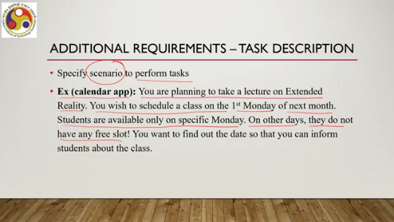
You want to find out the date so that you can inform students about the class. And you want to find that out using the calendar app. That is a task description or a scenario that you have to create for the prototype to be evaluated by the evaluators. So the task here is to identify the date on which the first Monday of next month falls.
And when we convert these two interface-level tasks, that is the things that we need to do to identify, to find out this information from the calendar app, what are the interface-level tasks we need to do? Select next month, locate first Monday, and mark the date. So, these are interface-level tasks.
Then what do we do? The procedure says that we give the scenario to the evaluators. The evaluators are asked to find out the date by performing the interface-level tasks with the prototype. Along with that, there are some additional requirements, that is, framing of some questions. So we also need to frame a set of questions which reflect usability issues beforehand.
Evaluators report on these issues while they perform the tasks. Some of those example questions with respect to our specific example application can be: Are you able to locate the month you are looking for easily? Is the interaction required to change from month view to day view apparent? Did you find it difficult to locate the first Monday? Was the date clearly visible along with the day?
Did you try to go back to the month view? Was the mechanism to go back clearly visible? So what is the purpose of these questions? The purpose is to identify problems users are likely to face. And these are a kind of guideline using which the evaluators can see from a user's point of view whether how easy are these questions to answer,
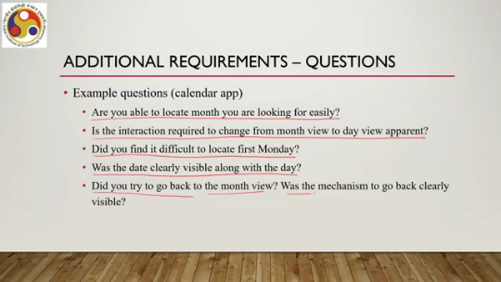
how easy it is to answer these questions, in what way these questions can be answered. However, the evaluators are not expected to answer only yes or no. They should give detailed report on what they felt about the interfaces and interaction with respect to each question. That is, if they face difficulty, where exactly, why they think that difficulty is there and so on. So, not a simple yes or no type answer, but a detailed report.
Now, the feedbacks from the evaluators that are received in the form of a report are analyzed to identify the broader usability issues. That is, of course, at the end of the evaluation session. So, all feedbacks from the evaluators are collected and then they are combined, compiled together and broader issues are identified. So, that is cognitive walkthrough. Another technique is heuristic evaluation.
So, here the basic idea is to evaluate a system with a checklist. In earlier cases, we have evaluated based on a scenario, task description, and a set of questionnaires. Here, no such scenario or task description is required. Instead, we can evaluate whatever prototype is presented to us, that means the evaluators use a checklist. Items in the checklist are called heuristics.
So, here the basic idea is that we perform a comprehensive evaluation of the whole system rather than task-specific evaluation. So, no need to create scenarios and ask evaluators to perform tasks. Instead, evaluators tick items on a checklist of features of the system as a whole. There are many such checklists available for evaluating interfaces. Some are detailed and system-specific.
Some are more focused on broader principles of usability. The latter category contains fewer heuristics because they are broader in nature, not specific to any particular interface. So one such, General set of heuristics is Nielsen's 10 heuristics. It is quite popular and was proposed way back in 1994, primarily related to GUIs.
However, they are equally applicable to most interactive systems, for most interactive systems. So, what are those 10 heuristics? Heuristic number 1. Visibility of system status: how visible the status of the system is to the user. Then two is match between system and the real world.
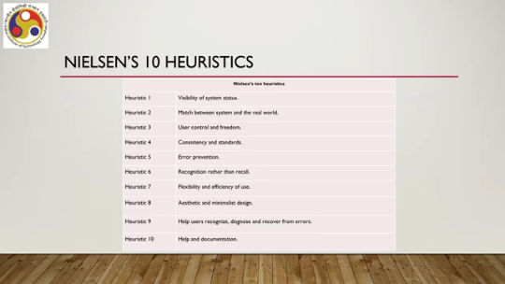
So whatever we do on the system, how closely it matches with our experience in the real world. Heuristic three: user control and freedom, whether the user is getting the freedom to do whatever they want to do and what kind of controls are provided to the user. Heuristic four. Consistency and standards: whether the elements, layout, whatever is shown are consistent across different screens and also standards are followed. Heuristic five is error prevention: whether the design helps the user prevent errors.
Heuristic six: recognition rather than recall. That means in order to perform a task, whether the user is forced to remember things rather than recognize from some element what to do. Note that recollection is always difficult as compared to recognition of certain activities. For example, just by looking at a button, we know that it needs to be pressed. However, if the button is not presented in a 3D mode, a 3D shape,
Then it is difficult to recognize just from the shape whether it needs to be pressed or something else needs to be done. In that case, the user has to recall what to do with the button from previous usage of similar systems. So, if the shape is not properly there, then the user will be forced to recall, which is not a good practice. Heuristic 7 is flexibility and efficiency of use. Heuristic 8 says aesthetic and minimalist design.
The design should have a minimum number of elements and should be aesthetically pleasing. Heuristic 9: help users recognize, diagnose, and recover from errors. Help users recover from errors; that is the main message. And the last, 10th heuristic, is help and documentation. So, for any system, there must be some help and documentation support provided.
So, these 10 heuristics can be used for identifying usability problems at an early stage of the design on the basis of simple low-fidelity prototypes. So, what we need to do is low-fidelity prototypes, primarily horizontal prototypes. However, vertical prototypes can also be there, but unlike the walkthrough method here. We do not require a vertical prototype mandatorily. It is optional.
But in the case of the walkthrough method, a vertical prototype must be there. We also need a team of evaluators with a similar team size, that is at least three to five members. They can be members of design teams or other skilled designers. So they can be designers or other expert designers, not necessarily involved in the design team. Here, the evaluation process is slightly different as compared to the cognitive walkthrough method.
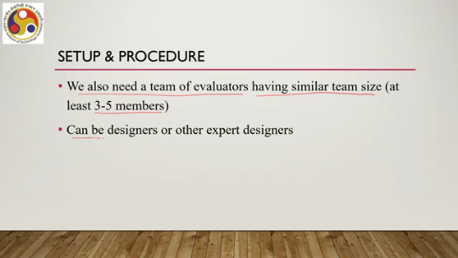
As we have noted, a task scenario is not required. Each evaluator checks the design, that is the prototype, with respect to the heuristics and reports their findings. Reports are combined to determine which heuristics are violated. So, each evaluator is given the prototype and the checklist, that is the heuristics; against each heuristic in the list, the evaluator evaluates and indicates whether the heuristic is followed or violated; if violated, what are the reasons.
So, one kind of some sort of commentary on the conformity or violation of the heuristic and for all the heuristics in the list, such a report is prepared by each evaluator, then all the evaluators' reports are combined, compiled, and major issues are identified. So, that is the heuristic evaluation technique. So, with that, we have come to the end of this part of the lecture.
So, in summary, we have covered so far the design-prototype-evaluate cycle. So, we have already discussed the importance of this cycle in interactive system development. In the previous lecture, we talked about design. In this part of the lecture, we completed our discussion on prototyping and also discussed quick evaluation techniques. So, how to build and evaluate prototypes we have also learned,
We learned about quick evaluation techniques. Two techniques we have covered. There are some more techniques that we are going to continue our discussion on in the next part of the lecture. So, I hope that you are able to follow the lectures and can enjoy the topics. So, looking forward to meeting you in the next part of the lecture.
Till then, thank you, goodbye, and happy learning.

